Socio-Economic Integration Strategy
South Caucasus Region; Georgia 2019-2021

Prepared for UNHCR South Caucasus Regional Representative Office
By: Ricarda McFalls, Socio-Economic Integration Consultant (September, 2018)

Table of Contents

Table of Contents 2
1. Acknowledgement 3
2. Executive Summary 4
3. Introduction 5
4. Context Analysis 6
5. Socio-economic Profile of Target Population 12
6. Market Analysis Findings and Recommendations 15
7. Institutional Mapping 19
8. Strategic Framework 21
8.1 Intervention and Monitoring Plan 23
9. SWOT Analysis ……………………………………………………………………………… 29
10. Annexes 30

Acknowledgement

Many thanks to all the individuals who generously offered their time, knowledge and experience including Government officials, NGO partners past and present, UN sister agencies, Private sector representatives, and Persons of Concern who participated in multiple focus groups, (see interview table in Annex).

This report would not be possible without the complete Multi-functional Team in Tbilisi, and the individual guidance and support of Johannes van der Klaauw, Yoko Akasaka, Marat Atamuradov, and Cristina Bunea of South Caucasus Representative Office and Georgia Operation. The entire Tbilisi operation played a critical role in supporting my mission throughout the region, including content, administrative and logistical support for which I express lasting gratitude. Special thanks to George Badurashvili (Program) for providing documentation, research support and paving the way to countless meetings and interviews in Georgia.

Any omissions, errors, or unintended misrepresentations are the authors own.

Executive Summary

Currently there are some 1,477 refugee and humanitarian status holders and 540 asylum-seekers in Georgia. The local legal environment is favourable to these populations with regard to the right to work and access to services and documentation, as well as freedom of movement in the country. However, the socio-economic environment is less favourable. While Georgia has enjoyed relatively high GDP growth rates, gains are not evenly distributed, unemployment remains high, and wages low. Refugees and asylum-seekers encounter various additional barriers in finding sources of income and livelihoods including: language skills, discrimination based on ethnic, religious or other differences, limited community links and social networks, lack of skills for the local market, and lack of access to vocational and other training opportunities. Refugees and asylum-seekers often rely on unsustainable seasonal and day labour jobs in the informal sector, such as trade, tourism, agriculture, construction, etc.
The initial livelihood assets that refugees and asylum-seekers can rely on - such as skills, financial capital, physical health, and social networks - are critical in widening their access to safe and productive work or income generating activities. In many cases however, these assets were either insufficient from the start, or have been eroded by displacement related factors. Assisting this population to recover or build on their existing assets, or develop new ones is critical to enabling them to better compete in a difficult environment, meet basic needs, as well as, achieve their human potential. In addition, youth unemployment in Georgia is more than double the general population, calling for more focus on this segment of the refugee population. With higher rates of poverty found in female-headed households, and with 44 per cent of women’s work unpaid, measures to increase opportunities for women’s participation in paid labour are recommended.
UNHCR supports the development and implementation of a sustainable livelihoods program for refugees and asylum-seekers in Georgia, transitioning from livelihoods-protection initiatives towards livelihood-promotion accessible through Government services. The July 2018 restructuring of government and dismantling of UNHCR’s primary interlocutor, the Ministry of Internally Displaced Persons from the Occupied Territories, Accommodation and Refugees of Georgia (“MRA”), has disrupted the pace at which the complete transition can occur. For this reason, the strategy provides two-track guidance on activities to be mainstreamed through government services today, and those which can be supported or enhanced with complementary support through other development agencies or NGOs, and transitioned to government over time. The strategy emphasizes the importance of ensuring PoC have access to basic public services and core livelihood-enabling activities, as pre-conditions for successful socio-economic integration.

Priorities include ensuring access to education for children and youth, Georgian language classes, building and enhancing skills through vocational education, and full access to public employment services. At the same time, complementary support services in partnership with NGOs and sister agencies include programs, with emphasis on youth and long-term unemployed, to help build confidence, local knowledge, and restore coping skills in preparation for employment. Finally, the private sector continues to seek pre-qualified candidates in certain segments of the economy, and have signalled willingness to partner on linking activities such as job-fairs and apprenticeships.

Introduction

This “Socio-Economic Integration/Livelihood” strategy is based on findings and recommendations emerging from extensive field research conducted in Georgia from January 22-26 (including PoC focus groups January 25 and 26); May 28 to July 20, and September 7 to 14, 2018. The strategy presented here has been developed in close consultation with a Multi-Functional Team at the Tbilisi operation and a wide range of key stakeholders, including the Government, NGOs, Development Agencies and Persons of Concern, in accordance with the Global Strategy for Livelihoods, the Operational Guidelines for Livelihood Programming in UNHCR, and the Minimum Criteria for Livelihoods Programming. The research and proposed strategy outlined in this document are to inform programming decisions of the Regional Operation for South Caucasus for the period 2019-2021. The findings and recommendations emerging from this research may also provide useful guidance for donors and development partners seeking to identify targeted programming opportunities for funding that can best serve the needs of UNHCR Persons of Concern.

The aim of the research was to assess socio-economic integration impediments and opportunities for target PoCs; provide strategic analysis and recommendations to address policy and programming gaps within the current economic context in Georgia; develop and propose pro-active advocacy campaigns and concrete programming initiatives; as well as, to optimize effective and efficient partnership opportunities where appropriate. The plan takes into account UNHCR Georgia’s strategic priorities for 2018-2019. It should be noted that during the course of this research, UNCHR’s primary interlocuter in the Government of Georgia since 1996, the Ministry of Internally Displaced Persons from the Occupied Territories, Accommodation and Refugees of Georgia (“MRA”) was recently dismantled and is now defunct, following a change of Government in June 2018. Over the following few months, the agency's various tasks were assigned to the ministries of Regional Development and Infrastructure, Interior Ministry, and Ministry of Labour, Health and Social Affairs, and new links are currently being established by UNHCR operations in Georgia accordingly.

The recent changes in government has underscored the fragility of earlier plans to completely transfer socio-economic integration responsibility to the Government. Nevertheless, the Strategy continues to reinforce the intentions to move towards sustainable self-reliance mechanisms.

Context Analysis

Persons of Concern: Status, Rights and Access to Services

In Georgia, 951 persons applied for asylum in 2017 (947 in 2016), the main countries of origin are Egypt, Iraq, Iran, Eritrea, and Turkey. The number of refugees and humanitarian status holders in Georgia has decreased from 1513 to 1477 mainly due to departure from the country. National security interests increasingly prevailed over refugee protection needs resulting in a significant decrease in the recognition rate of (18%), comparing to 2016 (43%). The Government provides limited assistance to asylum-seekers, and the integration related activities are underfunded and not addressed in a systemic manner. Whereas refugees benefit from social assistance on equal footing with nationals, and asylum-seekers have the right to work, in reality the full enjoyment of rights is limited by practical constraints, e.g. insufficient awareness among POCs and service providers of the available rights, obligations, and limited government funding. Access to education is not hindered, but enrolment in schools is challenged by language barriers. Access to public health care is ensured for asylum-seekers and status holders including access to universal medical insurance for status holders.

Access to protection information was noted as a major concern during the participatory assessment. A negative trend including anti-foreigners sentiment has been increasingly noted. In Georgia, social discrimination and prejudice, as well as homophobic rhetoric of officials and the Orthodox Church against LGBTI and anti-Muslim sentiments may raise concerns regarding the security of refugees and asylum-seekers belonging to these groups. Some recent progress in legislation and practice has been noted, e.g. 2016 and 2017 opening of the state crises shelters and safe houses for victims of trafficking and domestic violence; adoption of the 2016 Law on Violence against Women/Domestic Violence, 2017 ratification by Georgia of the Istanbul Convention, or as of 2018 access to free legal aid for victims of domestic violence and female victims of violence, irrespective of their financial situation. UNHCR expects a broader engagement in this area and mainstreaming PoCs into the national assistance and response schemes. As of 2017 refugees are included in the state social assistance scheme, but asylum-seekers have to rely on UNHCR’s support.

Economic Outlook

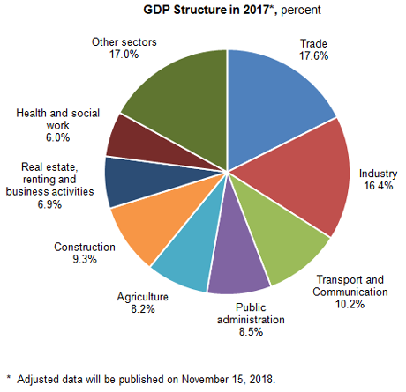
Georgia (population 3.7 million; GDP 15.5 Billion) enjoyed an average GDP Annual Growth Rate of 4.21 percent from 2006 until 2018. The economy performed better in 2017 than anticipated, and advanced 5.3 per cent in the first quarter of 2018. In 2017, exports of goods expanded by 24 per cent based on strong demand from Russia, Azerbaijan, Ukraine, China, and the United States, while exports of services improved by 20 per cent, led by a 27 per cent spike in tourism proceeds. Overall, Georgia’s leading trading partners are Turkey, Russia, Azerbaijan, and China (see chart below). Workers’ remittances were also up by 21 per cent in 2017. Overall, Georgia’s leading exports are: Extractives (Copper ores; Ferro-alloys;) Motor cars (re-export); Wine, and Medication; and main imports: Oil,
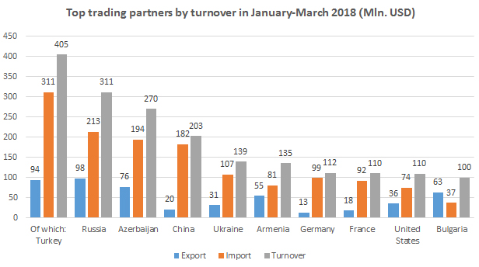
motor cars, pharmaceutical products, wheat and meslin, sugar and electrical equipment. Georgia had a growing trade deficit as during the first seven months of 2018, the deficit was recorded at USD 3.3 billion, compared to a USD 2.8 billion gap in the same period of 2017. Russia’s trade deficit and the low value of agricultural exports are blamed. Georgia’s growth outlook over the medium term is expected to be positive (over 5 per cent into 2020), and inflation that peaked at 6.7 per cent in 2017 is projected at 3 per cent in 2018. A more benign external environment should facilitate the development of private sector–led export sectors, encourage FDI, and support consumption. Provided the economy continues to expand at projected rates, more employment opportunities and further poverty reduction are expected. In rural areas, employment opportunities outside agriculture are expected to help support the regions.

Employment

While incomes have increased (see graphs below), GDP growth has not done much to expand the number of jobs and reduce unemployment in recent years.

Whereas official unemployment is published as 13.9 per cent for 2017, labour participation may not be well reflected in this figure. 51.7 per cent are considered to be ‘self-employed’ ; with 42 per cent are reported to be employed in agriculture; 24 per cent as ‘professionals, technicians, and clerks’ and 11.4 percent in the trades. Whereas overall unemployment is 13.9 per cent, youth (age 20-24) are twice as likely to be unemployed (29.6 per cent, according to GEOstat); Reflecting the strong role of agriculture in regional employment data, unemployment in Tbilisi is estimated to be 25 per cent.
While the volume of new jobs created in the economy is reported at only around one percent, labour market research indicates that some opportunities for individual job-seekers remains positive when skills are linked to demand . On the one hand, the 2015 labour market study indicates that the market for university graduates appears to be saturated, however demand for skilled workers in the services sector remained relatively strong, at both the higher and lower end of vocational skills: From medical practitioners, teachers, and accountants, to shop assistants, waiters, sweepers and related laborers. For industries with high levels of seasonality or difficult working conditions, a relative constant demand for workers was foreseen. Excerpts of the report, enumerating major job sectors and areas of demand are included in the Annex. The breadth of vocations for which there is demand provides important input when considering vocational options potentially available for UNHCR Persons of Concern.

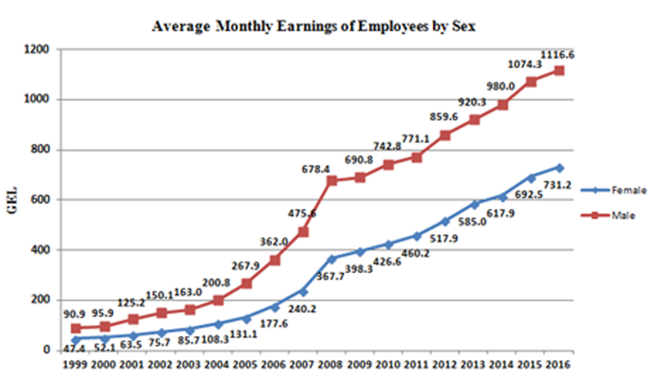
Low wages are a characteristic of the Georgian Labour Market. Whereas official wage data shows increases, the high percentage of ‘self-employed’ is not included in these statistics, and the majority of population, as reported to be working in agriculture, are at the bottom of the wage table. Overall, women fare worse than men as 44 percent of women’s work goes unpaid. Twenty percent of Georgian’s live in poverty, and between 47 and 54 percent are found to be at risk of falling into poverty. At the same time, official minimum wage has not been lifted in the legislation and remains at 20 GEL per month, facilitating the opportunity for those working in the informal sector to be openly exploited. During focus groups at the Martkopi Asylum Center, one PoC reported that he had accepted employment shovelling coal for a winter greenhouse, was kept on the job for 24 hours without break (‘in slave-like conditions’ according to his description), and then was shocked when his wage for 24 hours work was 20 GEL.
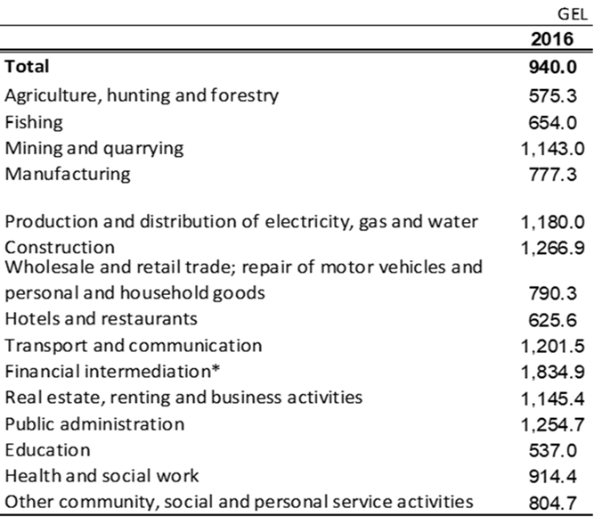
PoCs face genuine risks in the workplace. In its bid for growth, occupational health and safety legislation has fallen short in Georgia. New legislation is expected to come into force from 2019 providing increased oversight in eleven sectors considered hazardous. Labour rights activists are concerned the legislation does not go far enough, as the labour inspectorate is still only able to provide ‘recommendations’. Helping PoCs understand which codes are in place may help make refugees and asylum seekers to make informed decisions and to differentiate situations which are discriminatory and which fall within the legislation for all Georgians.

UNHCR Socio-Economic Integration Programming

Research presented here with respect to Socio-Economic Integration programs in Georgia is limited to 2017 and 2018, a period of transition. Following the May 2016 publication of the Study on Socio-Economic Integration Situation of Refugees, Humanitarian Status Holders, and Asylum-Seekers in Georgia (“The 2016 Study”), the operation began to actively shift programming related to Socio-economic Integration to the Government. During this period, the Office had two primary delivery partners: (1) United Nations Association Georgia (UNAG) “Open House”; and (2) the 2016 constituted “Integration Centre” with core funding from the MRA, which became operational in May 2017 under an NGO contractor model (in this case, Public Advocacy NGO being the ‘contractor’).

- UNAG and Open House

UNAG has been a UNHCR partner since 1998, providing a combination of legal and integration services. Under its current agreement with UNHCR, UNAG provides: a) comprehensive legal work, including free legal aid, strategic litigation, monitoring and legal advocacy of refugee rights; and b) empowering communities, focusing on overcoming isolation of refugees, and facilitating their long-term social, economic and, cultural contributions to the Georgian society.

The integration component is delivered through “Open House” a community centre strategically located near major metro stations in central Tbilisi. Community services offered include: language education (English and Russian, and previously Georgian), access to literature, computer skills, and information on vocational education. Their approach aims to be community-centric and encourages community building, community self-management, experience sharing and cultural exchange “among and beyond the refugee communities in Tbilisi and Rustavi”. The center aims to create a forum for information exchange among refugees, asylum seekers and humanitarian status holders, and facilitate to information on state services through information sessions and referrals. Open House reported it delivered 73 events under 12 components in the first half of 2018. Based on direct observation, the English language classes are fully subscribed to capacity. There continues to be high demand at this location for Georgian classes (which were previously conducted there prior to the establishment of the Government Integration Centre).

- Integration Centre

With the assistance of UNHCR in 2016 to refurbish an office and classroom space in 2016, the state-run Integration Centre opened in mid-2017 and the number of services provided, gradually increased. However, as a consequence of the change of Government and dismantling of the MRA in mid-year, the contractual status of the Integration Centre was disrupted in mid-2018 and UNHCR is currently attempting to secure bridging arrangements to restore services. Primary services included hosting the Government-sponsored Georgian language courses, as well as, community integration activities for adults and children. Participation in activities held at the Integration Centre is limited by its location– situated at the far periphery of Tbilisi, it requires up to four public transport transfers. With respect to livelihoods, the Centre conducted a survey and profiling among its beneficiaries and the results of this exercise should ultimately lead to a development of individualised integration plans. Based on the profiling exercise and a business plan competition, a small number of Income-generating grants were provided to refugees in late 2017.

A May 2018 monitoring exercise of the eight funded projects found five projects to be operational in some way and three not operational or on hold. The most successful appeared to be a butcher’s shop that had already been operational whereby granted tools were used to expand the business and increase profits, allowing the shop to employ another refugee and a Georgian national. Another going concern in honey production seemed to be functioning, if at lower turnover than anticipated. The beneficiary also found that the capital provided was insufficient to secure all the inputs required, which limited the operation. High risk, but also potentially high reward was the funding of a 140 head of sheep for reproduction and live export, however, no results were yet available as awaiting reproduction. A creative venture in the production of electronic toys had failed to consider the operating margin on the products, but the beneficiary appeared to be developing alternative schemes. Home sewing operations, while ostensibly low risk, appeared to lack sufficient marketing capacity. Two ventures failed to launch within first 6 months due to planning issues: A cafeteria that entered into lease arrangements prior to having sufficient resources, resulting in a lease dispute; a baker was unable to launch after failing to secure three-phase electricity.

Among lessons learned was that the beneficiaries were in many cases insufficiently prepared to launch operations at the time the grants were initiated. The monitoring exercise identified that beneficiaries had insufficient background in local law, business management and marketing. At the same time, income generating grants alone are often insufficient to support significant start-up costs. Depending on the type of business, start-up cash flow can be negative for three months to a year or more. The exercise further raises questions about delegating entrepreneurship and income-generating grants through NGOs with limited experience in this field. Though start-up failures are to be expected in any case, specialized business development agencies typically draw on a wider range of experts to ensure that projects are more thoroughly vetted, and ideally provide guidance throughout the start-up and early phase of the business. Additionally, UNHCR twelve month funding cycles are too short to directly facilitate a full cycle of enterprise development programming needed for success. It is recommended that follow-up monitoring be implemented with current cohort of beneficiaries, and for future programming, facilitate inclusion of PoCs in SME development programs conducted by Enterprise Georgia (or equivalent).

Socio-economic Profile of Target Population

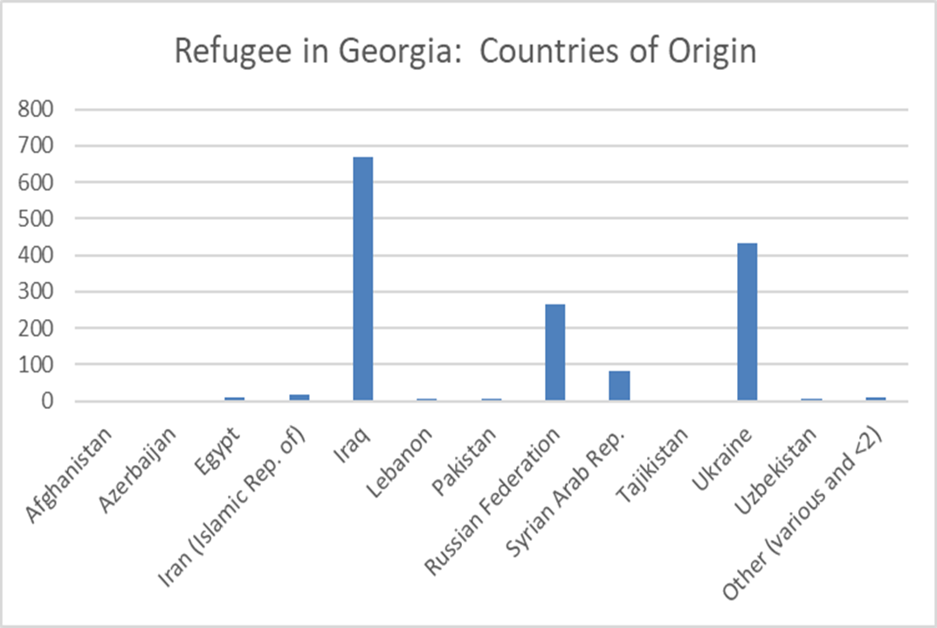
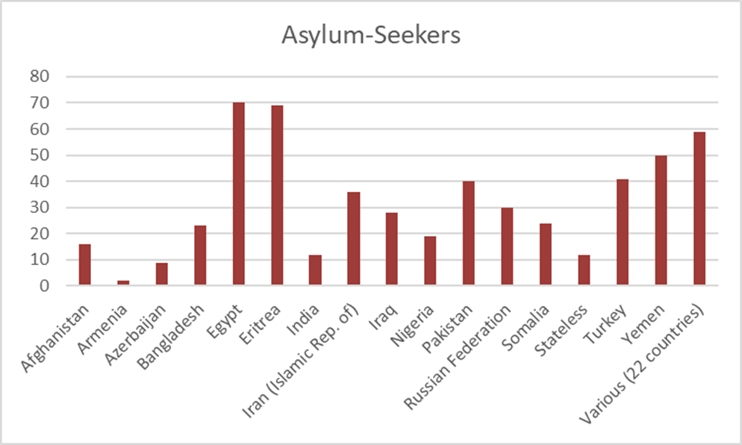
In Georgia, as of December 31, 2017, the largest population of refugees (630) originated from Iraq, followed by the Ukraine (389) and Russian Federation (259). By contrast, asylum-seekers are represented by small populations from a wide range of countries led by Egypt, Eritrea, Yemen, Pakistan, and Turkey. Men outnumber women by 54 to 46 per cent. Among the combined groups, the majority of PoCs are Arab speakers of Muslim faith and a good number of have developed improved networks through The Association of Arabs of Georgia.

Social workers have noted that more recent new arrivals among asylum seekers tend to be more vulnerable, with fewer skills and often illiterate.

Seventy per cent of all Persons of Concern are based in Tbilisi, another 20 per cent in nearby Kahketi region, and the balance distributed between Adjara (Batumi Area), and other regions.
In Tbilisi, approximately 20 per cent of Asylum-seekers are based in Martkopi, the temporary shelter provided by the Government. The remainder of Persons of Concern rent apartments from the private sector. Housing discrimination and complaints of price-gouging of foreigners is a common complaint. Often housing accounts for 50 per cent or more of all available funds. Fifty-one percent of respondents living in Tbilisi and 47% of respondents living in the regions report ‘very bad’ or ‘bad’ living conditions, while 21% of respondents in Tbilisi and 10% of respondents living in outer regions consider their conditions as ‘good’ or ‘very good’. Paradoxically, the same study concludes that access to most amenities (water, electricity, heating) is better than in their country of origin. With respect to income assets, less than 20 per cent surveyed have access to regular employment. The majority of PoCs are dependent on government assistance, social networks, or family in home country for support. However, as these transfers are not sufficient to cover basic expenses, it is expected that most households have access to some sort of part-time or seasonal work.

Social workers estimate that around 20-25 percent are among the most vulnerable, and include a number women-headed households with children, whose spouses may still be working as migrant workers in a third country. Among the next 40-45 per cent of households, have at least one adult working in low-end service jobs in the seasonal tourism industry using their Arabic skills, or are working in low pay, high risk construction jobs. As a consequence of new entry restrictions for some Gulf countries, tourism from this population was reported to be reduced resulting in fewer work opportunities. Within in this lower income category are also skilled tradesmen (plumbers and electricians), working as taxi drivers, as they report that Georgians ‘do not trust them’ to apply their skills. In the middle income sectors, are skilled and semi-skilled Ukrainians and Russians (some married to or related to Georgians) who are able to work without any serious language barriers, for example in services (e.g. hotels, make-up, or hairdressers). A number of Iraqi’s and Egyptians are also found in the ‘middle’ category and jobs include as teachers and musicians. At the higher end, ‘better off’ refugees reported procuring homes and opening restaurants.

PoC Employment and Barriers

Based on the most recent comprehensive survey on socio-economic integration of PoCs, though a majority arrived with a relatively high level of education and skills from their home country, only a small fraction of PoCs reported themselves to be employed: 8.2 per cent of women and 18.5 per cent of men. Before settling in Georgia, 63 per cent of refugees had a profession (teacher, engineer, accountant, lawyer, IT technology, designer, driver etc.), and approximately 67 per cent of the sample had been employed in their home country, almost half of these for ten years more. Among those who found employment in Georgia, only 24 per cent were working in the same profession as in their home country.

With regard to the obstacles to finding employment, refugees named lack of relevant language skills (49%) and the weak labor market (28%) as key barriers. Other reasons mentioned include dependents, such as young children (14%), the lack of job searching skills (11%), age (7%), low salary (7%) health issues (6%), studying (4%), lack of official documents, and the lack of skills or experience (2% each). Lack of Georgian language was also cited as a key barrier with respect to accessing education (and public services). Whereas the survey found 70 per cent of PoCs interviewed would like to attend vocational training, 64 per cent did not know about it (had not heard of its availability), and 28 per cent did not pursue it due to language constraints. 23 per cent indicated that lack of language skills was the main reason for not attending university. 47 per cent indicated that language barriers prevented them from obtaining public services.

Overall the 2016 Study on Socio-Economic Integration of PoCs concluded “The main obstacles to integration are low income, finding employment, language barriers, and difficulties in accessing medical services and education”, and repeatedly emphasized the importance of the language component: Language proficiency broadens social networks with the local population, improves access to social and legal services and, if coupled with English proficiency, increases the likelihood of employment. The 2018 Focus Group discussions came to the same conclusion. Participants ranked as their most important concerns:
- Language (Georgian) – access to classes
- Information about law and legal protection
- Services of State to Citizen (where to get OFFICIAL information, as they reported getting different information from different sources)

Market Analysis Findings and Recommendations

The UNHCR Operation faces certain challenges with respect to effective Socio-Economic Integration Programming in Georgia. Refugees and asylum-seekers in Georgia are a relatively small, heterogeneous, urban population, of diverse nationalities, primarily residing in Tbilisi and environs.
While Georgia has enjoyed positive GDP growth, the gains have been unevenly distributed, and in Tbilisi, where most refugees are based, unemployment is high. Linking refugee assets to opportunities is difficult; and, as incoming refugees today are even more diverse in nationality, ethnicity, language, and skills than more established refugees, more individualized integration planning approaches are needed. Furthermore, by mid-2018, the objective of fully transferring socio-economic integration activities to government in the short-run was upended when the government leadership changed and the MRA was dismantled and all funding by the government to its own “Integration Centre” was halted. This set-back emphasizes need for UNHCR to continue to provide services through multiple channels at least in the short-term.

In recent studies, Persons of Concern have identified priority needs in support of achieving socio-economic integration, including: (1) Access to Georgian language, (2) Information about and access to public services, including with respect to education, employment, housing, and healthcare; and (3) access to employment opportunities. Strategies to address these needs are proposed, with a further view to prioritizing support for youth in these populations. The strategy calls for more systematic data collection (access to a common registration system) with inclusion of PoC livelihood asset information in order to better analyse the ongoing needs and monitor the integration progress of individual Persons of Concern, as well as, to provide meaningful sex and age disaggregated data.

Finally, until the government refugee and asylum-seeker support infrastructure has stabilized further, the strategy calls for a two-track support strategy in the short- and medium term, combining mainstream provision of core services by government, with complementary programs delivered through partners during a full transition to government programs.

With respect to basic economic integration enablers, this study recommends beneficiary-centric approaches:

- Shift from “Integration Centre” (office-centric) perspective to ‘integration support services’ (client-centric) model. At present the hard ware (physical office) is rather an inhibitor to the software (social services): While the office can serve as a base for staff, provide service and support where refugees and asylum seekers need it. Integration Services concept should focus on multi-lingual individual counselling and advisory services to direct refugees to public services:
  - Housing: Information on legal and leasing; reputable agents for low-income housing; how to access affordable housing etc.
  - MOLHSA: Worknet, and Public Employment Services; information on right to work; minimum wages (Georgia Labour Code). Provide direct assistance to refugees to enable them to access these services.
  - Certification of Credentials: Jhvania schools participating in an international credential recognition program.
  - Education: Provide guidance on schools, entry requirements; community centres and extra-curricular classes for Youth; Nationally accredited Vocational Centers etc.
  - Health: Where to obtain access to health services; psycho-social and SGBV information and support.
  - Enterprise Georgia: SME Start-up support, coaching, and grants.
  - Georgian language courses: Guidance on where to obtain for free or low-cost; guidance on minimum requirements.
  - Information on how to access Georgia’s one-stop public centers and kiosks; information on transportation system and costs etc.
  - Documentation Support: Where to obtain necessary permits, identification documents and other legal support
  - Provide direct assistance – directly assist (accompany) if refugee has difficulties understanding or accessing services (serious issues).

Note: The above basic services should be made easily available to all PoCs, including in regions and rural areas. Consider long-term implementation through the MOLHSA and its 69 service points in Georgia.

- Language training: Accessible, age and level-appropriate Georgian language should be promoted. Georgian language was discontinued at centrally-located Open House as the government agreed to provide the training at its ‘integration centre’. As the instruction is conducted by certified instructors from a public educational institution, this instruction can presumably be conducted at other locations more accessible to refugees, including at Open House (or any other site close to Metro). Continue to offer English classes (and Russian) as many tourism related jobs require.
- Employment and employability (Youth 16-24; Adults 25-59):
  - Public Services: With support of integration support services (above), unemployed refugees shall be registered in the governments “Worknet” platform, which is a pre-requisite for obtaining social support. Whilst the number of jobs matched through this platform remains single digit, registration ensures that data is tracked while the government continues to upgrade its effectiveness. UNHCR has the opportunity to partner with the government on programs that it currently undertakes to include refugees, including Ministry of IDP, Labour, Health and Social Affairs:
    - Job Fairs: Collaboration with Georgian Chamber of Commerce, Georgian Employers Association, and other private sector actors; initiative to be coordinated in conjunction with preparation workshops for PoC job-seekers.
    - Paid Apprenticeships: MOLHSA provides paid placements for up to 6 months to facilitate employment opportunities; UNHCR to explore joint-funding possibilities for inclusion of PoCs among candidates.
    - Vocational short courses: MOLHSA provides selective short-courses to up grade skills of long-term unemployed; support public option where possible (otherwise enroll PoCs in Vocational training institutions with diploma; costs are capped to 1000 GEL)
  - NGO Services: Many refugees may have experienced prolonged employment breaks during displacement and require additional support to help them re-enter the workforce. Programs such as “Employment Shuttle” (Action Against Hunger) or “Start and Improve Your Business” (Georgian Employers Organization) may be options to consider for programmatic funding. Graduates should be referred to Enterprise Georgia for start-up support, should enterprise development be suitable. (Explore joint funding possibilities if required to include refugees; currently limited to citizens).
  - Strategic Partnerships: Georgian Chamber of Commerce; Georgian Employers Organization; UNHCR initiatives to partner with these organizations together with the Ministry of IDP, Labour, Health and Social Affairs, provides opportunities to increase linkages between refugees and employers, but also to advocate for the benefits that PoCs bring to Georgia. PoCs arriving with entrepreneurial skills will be introduced to Enterprise Georgia.

- Focus Target: Youth (16-24); Women (18-59):
  - Public Services: In the context of integration support services, first ensure that all children arriving in the territory are attending school (Protection). For youth completing secondary school, provide guidance and support to access Vocational Education or University (as appropriate).
  - NGO Services:
    - Community Centers (“Open House” model): Social and cultural centers; “safe space”. Provide after-school tutoring to assist children and youth in Georgian homework or to pass into appropriate level of school. Promote volunteerism in community with Georgians. Continue with “Women’s Club”, an initiative that allows for greater social-integration of women who are home-based due to family responsibilities or culture practices. Ensure child-minding services are available when scheduling events.
    - Youth Development: Support programs to build personal and vocational skills; counseling youth on vocational options. (e.g. World Vision SKYE, Employment Shuttle, Youth Palace, Access to Scholarships; Stipends for Vocational Training) ; sports and cultural activities.
    - Internships/Apprenticeships: Support job-linking activities, employer and employee stipends paid for 6 month to one year.
- Research and data Management:
  - The strategy further advocates for harmonizing data management in the region, and conducting surveys, including questions for assessing socio-economic integration, based on common questionnaire and in similar intervals.

The above breaks down activities between those which can be channeled through public services today and those which can be specifically focused on PoCs through NGOs. In both cases, a high level of engagement and monitoring is required by the UNHCR operation to ensure effective inclusion and participation of PoCs. In some cases, a combination of public, private, and NGO support may be pursued. For example, various Chambers of Commerce are receptive to participating in Job Fairs, with MOLHSA and UNHCR. At the same time, each entity may need support to bring together employers and job-seekers. Certain sectors continue to demand labour, some in high skill medical fields, education, or high tech; mid-skill fields of tourism, hotels and wine-making; and ongoing demand in difficult, low-skill work such as construction, or street-sweeping.

The strategy further promoting the inclusion of UNHCR PoCs among ‘vulnerable populations’ supported by International Organization Partners, and sister agencies. The importance of metrics and data management is promoted, with a view to explore standardizing regional Socio-Economic Integration Survey Instruments and implementation timelines.

Institutional Mapping

Strategic Framework

Vision

The UNHCR Global Livelihoods Strategy aims to ensure that all persons of concern are able to make a safe and sustainable living that meets their basic needs, contributes to their dignity, and provides for the full enjoyment of human rights.

Strategic Objective

All refugees have unhindered access to integration programmes that will be regulated in the national legislation; transition from emergency and humanitarian response to sustainable development, maintaining advocacy and monitoring roles regarding mainstreaming of persons of concern to UNHCR in national development programmes, where possible, with the objective of full assumption of delivery by the Government over next three years.

Outcomes, Outputs, and Key Programs

The Georgia operation will continue to work with the government to strengthen its investment in social services, and integration support services. The operation will conduct a verification exercise to develop a target baseline, and will promote the importance of good data collection and management among stakeholders. Programs will aim to engage beneficiaries in individual integration planning, with more emphasis on helping PoCs gain access to decent work, public services, health and education, including formal vocational education, available to all Georgians. Due to limited social networks available to refugees, the operation will assist the government’s “integration support services (center)” (and other integration partners), social workers and public employment agencies to link qualified refugees with decent work. Prospective entrepreneurs will be introduced to national SME development programs (Enterprise Georgia or equivalent). UNHCR will continue to assist in capacity building of partners and coordinating programming among agencies and NGOs serving PoCs in Georgia.

Livelihood Programming Objective:

UNHCR Georgia’s livelihood strategy will aim at providing PoCs with mid-term and long-term self-reliance mechanism through protecting their social and human assets and increasing or diversifying their sources of income, and promote decent work strategies. UNHCR, facilitating through the integration centre (or equivalent) and integration partners, will continue supporting PoCs to achieve self-reliance and improved livelihoods through the following

Outputs:

- Assessment and analysis undertaken (Short-term, medium-term, long-term): Socio-economic profile and livelihood capabilities will be conducted to develop a baseline. The Georgia operation will conduct focus groups as part of participatory assessments in order to better develop, understand and monitor the target population. A partial survey was completed in 2018 by Public Advocacy NGO. It is proposed that the Region support development of a common socio-economic integration survey instrument to be implemented at common agreed intervals.

- Strategy developed and implemented (Short-term; medium- and long-term): The strategic plan for livelihoods program is informed by regular assessments. Public sector partners (Short-; medium-; and long-term) are in engaged in strategic planning and implementation. Private sector partners are engaged in strategic planning and implementation (medium-term; long-term). Strategic plan is informed by assessment (short-;medium-; and long-term)

- Advocacy conducted (Short-term; medium- and long-term): PoCs are included in programming of government and other development actors; the Georgia operation continues to work with sister agencies, NGOs, donors, and government agencies for the inclusion of PoCs in programming, including SME development loans and grants, short- and long vocational courses, job placement schemes and other programs available to citizens.

- Access to training and learning enabled (short; medium, and long-term); number of adult PoCs enrolled in language training for livelihood purposes. Official qualification through accredited language school.

- Access to wage earning employment is facilitated (short; medium; and long-term). PoCs are registered in job placement services through “WORKNET” and Public Employment Service; PoCs are enrolled in apprenticeships and on the job training schemes; PoC are provided with guidance on the labour market. Job Fairs are coordinated by the Ministry and supported by Georgian Employers Organization, Georgian Employers and others.

- Vocational training/technical skills are provided (medium; and long-term). PoCs are enrolled in formal national institutions for certified skills training; Vocational and technical training institutions provide training at reduced rates; Youth (15-24) attend vocational and technical skills training. It is foreseen that identifying appropriate partners is carried out in short-term (2019), with implementation in subsequent years.

- Access to self-employment/business facilitated (short-term; medium-term). PoCs receive guidance on business market opportunities through qualified intermediaries. PoCs may receive entrepreneurship and business training. Note: Ideally Enterprise Georgia is the correct partner, however, currently only supporting Georgian citizens. Possibility to negotiate inclusion of refugees, though may require supporting funds. Alternative is to run the programming through one of the four NGOs implementing on behalf of Enterprise Georgia.

Note: No indicator added with respect to ‘access to financial services’ at this time; To be considered for long-term inclusion, but is currently out of scope until next step progress on Enterprise development partnerships. (To be discussed)

Intervention and Monitoring Plan

Short-term interventions (July 1, 2018 – December 31, 2019)
- Strategic Objective: Potential for integration realized
Output | Target Group | Intervention Activities | Performance Indicators | Impact Indicators | Potential Partners
Assessment and analysis undertaken | All PoCs 16-59 in Tbilisi and main rural areas | PoC verification exercise including livelihood assets; PoC focus groups; Survey instrument | # of studies on integration process produced | Extent Economic and Social Integration Realized | Propose use of regional research organization, such as CRCC.
Strategy developed and implemented | Key external stakeholders engaged in planning process: Public Sector, NGOs, and Private Sector | Stakeholder meeting to review strategy conducted and feedback incorporated | Local integration strategy established and endorsed by PoC; development actors, government and other relevant stakeholders (yes/no) | Extent Economic and Social Integration is realized | Direct partners:  Government (Refugees counterpart); Ministry of IDP, Labour, Health and SA;
Advocacy conducted | Youth; women; PoCs (16-59) | PoCs are included in programming of government and other development actors; including mainstreaming into programs that do not accept non-citizens | # of events; workshops and seminars organized | Extent social and economic integration is realized | Partners: MOLHSS, MIA, Ministry of Education; Enterprise Georgia; World Bank, UNDP, GIZ, and others
- Strategic Objective: Self-reliance and Livelihoods improved
Output | Target Group | Intervention Activities | Performance Indicators | Impact Indicators | Potential Partners
Access to wage earning employment is facilitated | Unemployed, poor, skilled refugees (18-59 years of age) living in Tbilisi | Establish individual economic integration plan for targeted PoCs; Through social counsellors, register job-seekers via Worknet. Actively followup with PES on job-matching performance.  Refer job-seekers to NGOs with internships and job-matching programs | # of refugees registered in job placement services.  # of refugees  Enrolled in apprenticeship/ training schemes | Extent persons of concern have formal access to work opportunities in host country | MOLHSA, Public Employment Service “Worknet”; Integration support services partner (“Integration Centre”; Open House?)
Access to training and learning enabled | UNHCR recognized refugees | Refugees have access to adult-centric learning of Georgian language at appropriate level with no more than 15 students per class. (English and Russian) | # of PoCs provided with language trainings for livelihood purposes. | Extent persons of concern have formal access to work opportunities in host country | Jhvania Language School; Ministry of Education
Access to self-employment or business facilitated | Recently arrived; Skilled refugees (18-59) with prior business experience and some financial capital | Introduce to ENTERPRISE GEORGIA for participation in business development programming. | # of PoCs provided with business training and number of PoCs provided guidance on market opportunities in Georgia | Extent persons of concern have formal access to work opportunities in host country | Enterprise Georgia (or equivalent)
Vocational training/technical skills are provided | PoCs who through acquisition of new skills can be matched with the labour market; focus on Youth (15-24) and women (15-59) | Vocational institutions are identified; reduced or waived fees are negotiated. PoCs sign completion commitment as part of individual integration plan. | # of PoCs enrolled in formal national institutions for certified skills training;  % of vocational and technical skills training students who are youths aged 15-25 . | Extent persons of concern have formal access to work opportunities in host country | To be identified; Minister of Education; Ministry of Labour
Middle-term interventions (January 1, 2020-December 31, 2020)
- Strategic Objective: Potential for integration realized
Output | Target Group | Intervention Activities | Performance Indicators | Impact Indicators | Potential Partners
Assessment and analysis undertaken | All PoCs 16-59 in Tbilisi and main rural areas | PoC verification exercise including livelihood assets; PoC focus groups; Survey instrument | # of studies on integration process produced | Extent Economic and Social Integration Realized | Propose use of regional research organization, such as CRCC.
Strategy developed and implemented | Key external stakeholders engaged in planning process: Public Sector, NGOs, and Private Sector | Stakeholder meeting to review strategy conducted and feedback incorporated | Local integration strategy established and endorsed by PoC; development actors, government and other relevant stakeholders (yes/no) | Extent Economic and Social Integration is realized | Direct partners:  Government (Refugees counterpart); Ministry of IDP, Labour, Health and SA;
Advocacy conducted | Youth; women; PoCs (16-59) | PoCs are included in programming of government and other development actors; including mainstreaming into programs that do not accept non-citizens | # of events; workshops and seminars organized | Extent social and economic integration is realized | Partners: MOLHSS, MIA, Ministry of Education; Enterprise Georgia; World Bank, UNDP, GIZ, and others
- Strategic Objective: Self-reliance and Livelihoods improved
Output | Target Group | Intervention Activities | Performance Indicators | Impact Indicators | Potential Partners
Access to wage earning employment is facilitated | Unemployed, poor, skilled refugees (18-59 years of age) living in Tbilisi | Establish individual economic integration plan for targeted PoCs; Through social counsellors, register job-seekers via WORKNET database. Actively followup on job-matching performance.  Refer job-seekers to NGOs with internships and job-matching programs | # of refugees registered in job placement services.  # of refugees  Enrolled in apprenticeship/ training schemes | Extent persons of concern have formal access to work opportunities in host country | MOLHSA; Public Employment Service (supported by Integration Support Services)
Access to self-employment or business facilitated | Recently arrived; Skilled refugees (18-59) with prior business experience and some financial capital | Introduce to Enterprise Georgia for participation in business development programming. | # of PoCs provided with business training and number of PoCs provided guidance on market opportunities in Georgia | Extent persons of concern have formal access to work opportunities in host country | Enterprise Georgia
Vocational training/technical skills are provided | PoCs who through acquisition of new skills can be matched with the labour market; focus on Youth (15-24) and women (15-59) | Vocational institutions are identified; reduced or waived fees are negotiated. PoCs sign completion commitment as part of individual integration plan. | # of PoCs enrolled in formal national institutions for certified skills training;  % of vocational and technical skills training students who are youths aged 15-25 . | Extent persons of concern have formal access to work opportunities in host country | To be identified; Minister of Education; Ministry of Labour
Long-term interventions (January 1, 2021-December 31, 2021)
- Strategic Objective: Potential for integration realized
Output | Target Group | Intervention Activities | Performance Indicators | Impact Indicators | Potential Partners
Advocacy conducted | Youth; women; PoCs (16-59) | PoCs are included in programming of government and other development actors; including mainstreaming into programs that do not accept non-citizens | # of events; workshops and seminars organized | Extent social and economic integration is realized | Partners: MOLHSS, MIA, Ministry of Education; Enterprise Georgia; World Bank, UNDP, GIZ, and others
(2M5_ GEORGIA Socio Economic Integration Strategy_Sept 25_2018) Strategic Objective: Self-reliance and Livelihoods improved
Output | Target Group | Intervention Activities | Performance Indicators | Impact Indicators | Potential Partners
Access to training and learning enabled | UNHCR recognized refugees | Refugees have access to adult-centric learning of Georgian language at appropriate level with no more than 15 students per class. (English and Russian) | # of PoCs provided with language trainings for livelihood purposes. | Extent persons of concern have formal access to work opportunities in host country | Jhvania Language School; Ministry of Education
Access to wage earning employment is facilitated | Unemployed, poor, skilled refugees (18-59 years of age) living in Tbilisi | Establish individual economic integration plan for targeted PoCs; Through social counsellors, register job-seekers via WORKNET database. Actively followup on job-matching performance.  Refer job-seekers to NGOs with internships and job-matching programs | # of refugees registered in job placement services.  # of refugees  Enrolled in apprenticeship/ training schemes | Extent persons of concern have formal access to work opportunities in host country | MOLHSA; Public Employment Service (supported by Integration Support Services)
Access to self-employment or business facilitated | Recently arrived; Skilled refugees (18-59) with prior business experience and some financial capital | Introduce to ENTERPRISE GEORGIA for participation in business development programming. | # of PoCs provided with business training and number of PoCs provided guidance on market opportunities in Georgia | Extent persons of concern have formal access to work opportunities in host country | Enterprise Georgia (or equivalent)
Vocational training/technical skills are provided | PoCs who through acquisition of new skills can be matched with the labour market; focus on Youth (15-24) and women (15-59) | Vocational institutions are identified; reduced or waived fees are negotiated. PoCs sign completion commitment as part of individual integration plan. | # of PoCs enrolled in formal national institutions for certified skills training;  % of vocational and technical skills training students who are youths aged 15-25 . | Extent persons of concern have formal access to work opportunities in host country | To be identified; Minister of Education; Ministry of Labour

- SWOT Analysis for Intervention Plan

STRENGTHS | WEAKNESSES
- Government services are strengthened and supported.  - PoCs are mainstreamed through public services with equal rights to nationals.  - PoCs are systematically linked to employment opportunities.  - Youth are supported through transition from school to employment through vocational training  - PoCs receive improved quality of training through national vocational institutions with recognized certificates.  - UNHCR assists entrepreneurs in accessing business support services through nationally supported institution. | - Integration Support Services and individual integration planning capabilities not yet developed.  - Government services are currently unstable following major re-organization; level of support to PoCs may not be as high in short-term.  - Quality of employment outcomes following vocational training still unknown.
OPPORTUNITIES | THREATS
- More employment opportunities for PoCs  - Reduced NGO dependency  - Successful transition to livelihood promotion  - Less dependency on UNHCR should funding be reduced. | - Employment opportunities get worse.  - Government fails to make any further investment in strengthening capacity of integration centre; WORKNET not strengthened  - ENTERPRISE GEORGIA unwilling to support refugees or program is discontinued.  - Inadequate human and financial resources to support activities

Annexes

Employment trends as reported on page 14 - Minstry of Labour, Health and Social Affairs of Georgia, 2015. The Survey Report of Labour Market Demand Component.

Demand for Vocational Skills (page 11)

ANNEX 2 – Livelihood Assets
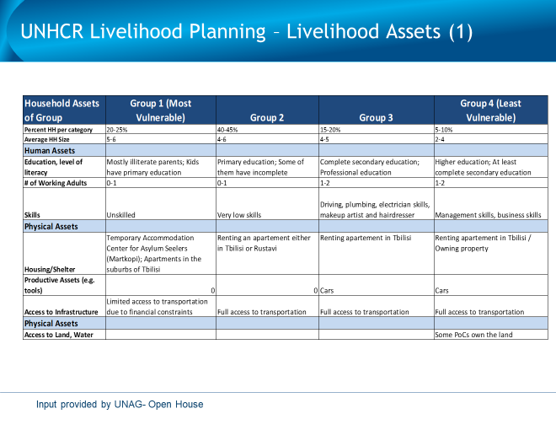

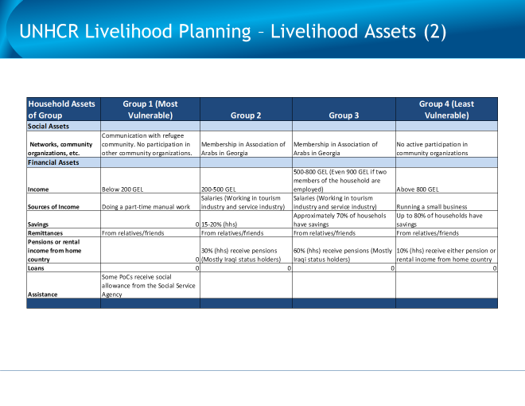

Based on MRA data of April 30, 2018 for Georgia TAT: December 31, Refugees are 2091, IDPs 278,103; Stateless 587, however, these statistics include Abkhazia. For purposes of this report, Abkhazia data is covered under separate report.
Based on MRA data of December 31, 2017 (intervals of data updates vary).
National Statistics Office of Georgia (GeoStat). 2016. Integrated Household Survey; and World Bank. 2016. Georgia Country Gender Assessment. Washington, DC: World Bank; in World Bank, Report No. 121853‐GE, April 25, 2018.
For the protracted IDP population, UNHCR has gradually disengaged from providing assistance, including through livelihood support, as this has now been taken over the Government, supported by the wider development community.
Tbilisi, Georgia also served as interim home-base between field missions to Georgia, Azerbaijan, and breakaway region of Georgia, Abkhazia. Total field mission for all countries January 21 to September 28, 2018.
Prime Minister Giorgi Kvirikashvili stepped down on June 13 and was replaced by Mamuka Bakhtadze on June 20, 2018 (both of the Dream Party).
Source: World Bank: https://wits.worldbank.org/CountrySnapshot/en/GEO; and, http://www.worldbank.org/en/country/georgia/overview
Trading Economics 5.3 per cent Q1 2018; Republic of Georgia Ministry of Economy and Sustainable Development quotes 5.3 per cent growth estimate based on IMF data: see http://www.economy.ge/?page=ecoreview&s=37
Ministry of Economy and Sustainable Development. http://www.economy.ge/?page=ecoreview&s=20
Trading Economics based on World Bank Data. Output expanded at a faster pace for mining & quarrying (11.4 percent from 2.8 percent in Q1 2017); hotels & restaurants (10.9 percent from 10.3 percent); financial intermediation, services indirectly measured (13.6 percent from 1.3 percent); public administration (3.4 percent from 0.5 percent) and real estate, renting & business activities (13.4 percent from 6.2 percent).
World Bank forecast 5 per cent; IMF 5.3 percent
Employment data: Graphs and charts Source, GEOStat: http://www.geostat.ge/index.php?action=page&p_id=149&lang=eng and interviews with MoLHS.
https://www.worldbank.org/en/country/georgia/overview
Employed (hired or self-employed) – is a person at the age of 15 or above who worked 7 days prior to the interview process (for at least one hour) to generate income (salary, profit or other compensation in kind), or helped other household members for free, or was formally considered employed but for some reason did not attend the work
Ministry of Labour, Health and Social Affairs of Georgia, interview July 3, 2018
Ministry of Labour, Health and Social Affairs of Georgia, 2015. The Survey Report of Labour Market Demand Component.
World Bank. 2016. Georgia Country Gender Assessment. Washington, DC: World Bank.
Tiwari, Sailesh; Cancho, Cesar; Meyer, Moritz; Fuchs, Alan. 2018. South Caucasus in Motion: Economic and Social Mobility in Armenia, Azerbaijan and Georgia. Policy Research Working Paper; No. 8329. World Bank, Washington, DC; in World Bank, Report No. 121853‐GE, April 25, 2018.
Martkopi Asylum Center Focus Group Meeting, January 26.
Georgia Labour Code update information via interviews with ILO. Additional input: http://oc-media.org/georgias-parliament-adopts-labour-safety-law/ [accessed September 16, 2018]
UNHCR and UNDP, May 2016. Study on Socio-Economic Integration Situation of Refugees, Humanitarian Status Holders, and Asylum-Seekers in Georgia.
See Annex: Livelihood Assets table prepared with assistance of UNAG ‘Open House’.
Unless otherwise indicated, this section and the Livelihoods Asset table in the Annex was compiled from discussions with Social Workers at Open House in August 2018.
UNHCR PoC Focus Groups, January 25, 2018, with Ministry of Internally Displaced Persons from the Occupied Territories, Accommodation and Refugees of Georgia (MRA).
UNHCR and UNDP, May 2016. Study on Socio-Economic Integration Situation of Refugees, Humanitarian Status Holders, and Asylum-Seekers in Georgia.
Ibid. The study found that although Refugees named it as the number one barrier by a wide barrier, lack of Georgian may not be a stand-alone cause, as non-Georgian speakers also were employed.
Author notes: UNHCR PoC Focus Groups, January 25, 2018, with Ministry of Internally Displaced Persons from the Occupied Territories, Accommodation and Refugees of Georgia (MRA).
As per 2015 Study and a 2018 survey of more than 200 PoCs, and 2018 UNHCR/MRA Focus Groups
The Integration Centre (Public Advocacy NGO) conducted a telephone survey in 2018 which captured some 200+ PoCs. It is proposed that in future a standardized instrument be developed for the region.
Enterprise Georgia only supports Georgian Citizens at this time. Opportunity to work out arrangement with them, OR contract directly the NGOs that deliver their program (but this uses UNHCR funds)

